# DOM and Events - Lab

Problems for in-class lab for the ["JS Front-End" course @ SoftUni](https://softuni.bg/trainings/3976/js-front-end-february-2023). Submit your solutions in the SoftUni judge system at <https://judge.softuni.org/Contests/3794/DOM-and-Events-Lab>

**Environment Specifics**

Please, be aware that every JS environment may **behave differently** when executing code. Certain things that work in the browser are not supported in **Node.js**, which is the environment used by **Judge**.

The following actions are **NOT** supported:

* **.forEach()** with **NodeList** (returned by **querySelector()** and **querySelectorAll()**)
* **.forEach()** with **HTMLCollection** (returned by **getElementsByClassName()** and **element.children**)
* Using the **spread-operator** (**...**) to convert a **NodeList** into an array
* **append()** in Judge (use only **appendChild()**)
* **prepend()**
* **replaceWith()**
* **replaceAll()**
* **closest()**
* **replaceChildren()**
* Always turn the collection into a **JS array** (forEach, forOf, et.)

If you want to perform these operations, you may use **Array.from()** to first convert the collection into an array.

1. **Sum Numbers**

Write a JS function that **reads** two numbers from input fields in a **web page** and puts their **sum in another field** when the user **clicks** on a button.

**Input/Output**

There will be no input/output, your program should instead **modify** the DOM of the given HTML document.

**Examples**

## Show More

Write a JS function that **expands** a hidden section of text when a link is **clicked**. The link should **disappear** as the rest of the text shows up.

### Input/Output

There will be no input/output, your program should instead **modify** the DOM of the given HTML document.

### Examples



**↓**



## Collect List Items

Write a JS function that scans a given **HTML list** and **appends** all collected list items’ text to a **textarea** on the same page when the user **clicks** on a button.

### Input/Output

There will be no input/output, your program should instead **modify** the DOM of the given HTML document.

### Examples

## List of Items

Write a function that **reads** the text inside an input field and **appends** the specified text to a list inside an HTML page.

### Examples

## Delete from Table

Write a program that **takes** an **email** from an **input field** and **deletes** the matching row from a table.

* If entry is found, the **textContent** in the element with **id="result**" must be set to **"Deleted."**
* Otherwise, an **error** should be displayed in a **<div>** with **id="result"**. The error should be **"Not found."**

Submit **only** the **deleteByEmail()** function in Judge.

### Input/Output

There will be no input/output, your program should instead **modify** the DOM of the given HTML document.

### Examples

## Add / Delete

Extend the previous problem to display **a [Delete] link** after each list item. **Clicking** it should **delete** the item with no confirmation. You have to add **href="#"** to the link element.

### Examples

## Colorize Table

Write a JS function that **changes the color** of all **even** rows when the user **clicks** a button. Apply the color "**Teal**" to the target rows.

### Input/Output

There will be no input/output, your program should instead **modify** the DOM of the given HTML document.

### Examples

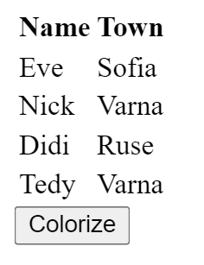 🡪 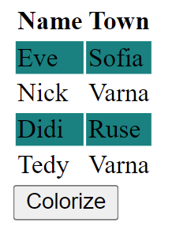

## Sum Table

Write a JS function that finds the first table in a document and sums the values in the last column. The result is then displayed in an element with ID "**sum**".

### Input/Output

There will be no input/output, your program should instead **modify** the DOM of the given HTML document.

### Examples

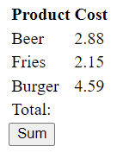 **→** 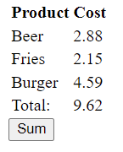

## Highlight Active

Write a **function** that **highlights** the **currently active** section of a document. There will be **multiple** divs with **input fields** inside them. Set the **class** of the **div** that contains the **currently focused** input field to "**focused**". When the focus is lost (**blurred**), **remove the class** from the element.

Submit only the **focused()** function in Judge.

### Input/Output

There will be no input/output, your program should instead **modify** the DOM of the given HTML document.

### Example

